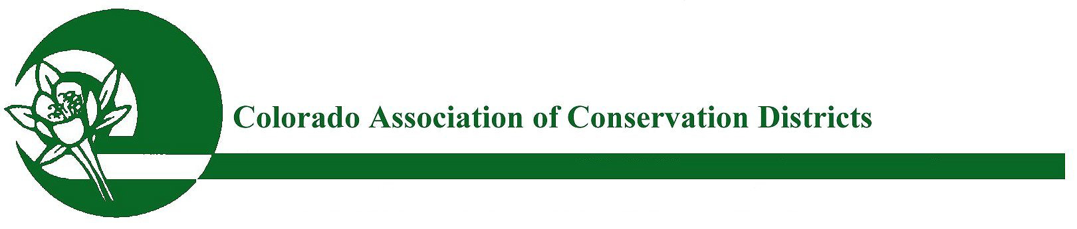
Mailing address: P.O. Box 1175, Lamar, CO 81052

CACD 2021 Educator of the Year ~ Award for Excellence

PURPOSE:
The purpose of this award is to recognize an Educator with outstanding and innovative conservation and agricultural initiatives and activities that have proven successful in reaching out to a variety of audiences, involving new partnerships, and spreading the conservation message. The Educator that is honored will serve as a model of excellence for other Conservation Districts Educators.

ELIGIBILITY:
All Districts are eligible to participate in this program. The nominee voted through by the watershed to CACD is eligible for receiving the state award unless the nominee has won the “CACD Educator of the Year” award in the past three years.

APPLICATION & NOMINATION PROCESS:
To nominate your Educator please complete the attached nomination form & submit to your watershed for voting. Please check with your watershed for their deadline date.

Nominations should include a description (1000 words or less) of how your nominee has implemented conservation education programs, community outreach and education events (e.g., tours, school field days, etc.), the length of time that the educator has utilized land steward and sound conservation education methods, and any long-term conservation goals and plans. The attached nomination word doc form is to be submitted to your watershed and should include a description (1000 words or less) of your District’s success in programs, tours, outreach, and projects. Letter(s) of recommendation from partner agencies and/or agricultural affiliates may be included. Please also submit up to five (5) pictures; in addition to a brief paragraph for promotional purposes.

Once the winner has been chosen by your watershed, the nominating district will need to submit this nomination form (word doc), along with supporting letters & pictures to CACD no later than October 1st.

JUDGING & AWARDS:
Entries will be judged by the CACD Awards Committee. Once a winner is chosen by CACD (by Oct 20th); The nominating district will be asked to summarize this word doc form down to 500 words or less and then submit back to CACD no later than October 26th. The winning educator will receive a plaque and be recognized at the CACD Annual Meeting, in November 2021.

REMINDER: SUBMISSION DEADLINE FOR STATE JUDGING:
Winners chosen from watersheds must be submitted to CACD no later than October 1st, 2021.
Submit nominations to: CACD ED, Bobbi Ketels – bobbi@coloradoacd.org

2021 CONSERVATION EDUCATOR OF THE YEAR NOMINATION FORM
Program Educator Name:

Address:

City/Town/State/Zip:

Telephone:

Email:
*********************************************************************************

Conservation District:

District Manager:

Address:

City/Town/State/Zip:

District Phone:

Email:

Website:

Endorsement:
(Conservation District Board President)

Date:

Nominee’s information may be typed here as a continuation of this word doc or
attached in a separate word doc form.

Supporting letters of recommendation may be in PDF format.
Pictures submitted must be in JPG format:

Submit watershed nominations to CACD ED, Bobbi Ketels – bobbi@coloradoacd.org

***

