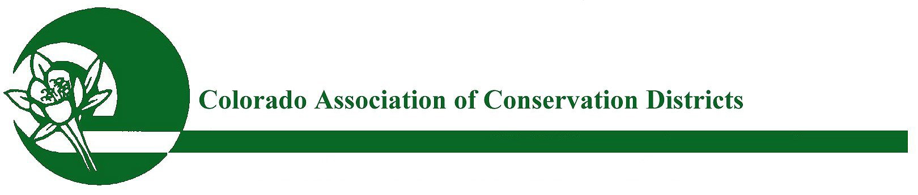
Mailing address: P.O. Box 1175, Lamar, CO 81052

CACD 2021 Supervisor of the Year ~Award for Excellence

PURPOSE:
The purpose of this award is to recognize outstanding and innovative conservation and agricultural efforts and activities by a Supervisor that have been proven successful in reaching a variety of audiences, engaging new partnerships, and spreading the conservation message. Supervisors that are honored will serve as models of excellence for other Conservation District Supervisors.

ELIGIBILITY:
All Districts are eligible to participate in this program. The nominating district must submit their nominated supervisor directly to CACD. This nomination does not go through the watershed.
The Supervisor Nominee is eligible for receiving the state award unless the nominee has won the “CACD Conservation Supervisor of the Year” award in the past three years.

APPLICATION & NOMINATION PROCESS:
To nominate your District Supervisor, please complete the attached nomination form & submit to CACD for voting. The attached nomination word doc form is to be submitted Directly to CACD and should include a description (1000 words or less) of how your nominee has the set him/herself apart from the other Supervisors in the District, describe what offices has the Supervisor held within District, Watershed, CACD and CSCB, describe how this Supervisor has helped put conservation on the ground, describe length of time with their District, their attendance record, and any long term conservation goals and plans that further the message of conservation to cooperators. Letter(s) of recommendation from partner agencies and/or agricultural affiliates may be included. Please also submit up to five (5) pictures; in addition to a brief paragraph for promotional purposes. All documents are due to CACD no later than October 1st.

JUDGING & AWARDS:
Entries will be judged by the CACD Awards Committee. One award is given each year in the Supervisor of the Year category to the highest scoring nominee that meets the minimum criteria excellence levels. Once a winner is chosen by CACD (by Oct 20th); The nominating district will be asked to summarize this word doc form down to 500 words or less and then submit back to CACD no later than October 26th. The winning Supervisor will receive a plaque and be recognized at the CACD Annual Meeting, in November 2021.

REMINDER: SUBMISSION DEADLINE FOR STATE JUDGING:
Winners chosen from watersheds must be submitted to CACD no later than October 1st, 2021.
Submit nominations to: CACD ED, Bobbi Ketels – bobbi@coloradoacd.org

CONSERVATION DISTRICT 2021 SUPERVISOR OF THE YEAR
NOMINATION FORM

Nominated Supervisor Name:

Conservation District:

Address:

City/Town:

State:

Zip:

Telephone:

Email:

Website:

District Manager:

District Phone:

Endorsement:
(Conservation District Board President)

Date:

Nominee’s information may be typed here as a continuation of this word doc or
attached in a separate word doc form.

Supporting letters of recommendation may be in PDF format.
Pictures submitted must be in JPG format:

Submit watershed nominations to CACD ED, Bobbi Ketels – bobbi@coloradoacd.org

***

