Please send me an Application Form!

Name
(Please print clearly)
Address _________
City
County
State Zip
Phone:
E-mail:
Date of Birth
Have you attended Camp Rocky before? YES ___ NO___
Note: The content of the Camp Rocky educational program is based upon and compliant with Colorado educational standards.

Please direct any questions to:

Amy Gossman, Camp Director amy.camprocky@gmail.com

Bobbi Ketels, CACD Executive Director
Executivedirector4cacd@gmail.com

Participation in Camp Rocky is open to all 14 – 19 year old teens, without regard to race, national origin, sex, religion, marital status, or disability.

IMPORTANT: Prior to attending camp, every camper MUST have a current physical exam by a licensed medical doctor. Submit your registration EARLY so that we may send you your health forms right away!

July 8 – 14, 2018
Near Divide, Colorado

2018 Camp Rocky Details:

Who can come?
8th Grade graduates by June 2018, 14 – 19 YO’s
Where is it?
Camp Rocky is held outside Divide, CO, about 45 minutes west of Colorado Springs.
How much does the camp cost?
$350.00 (all inclusive) Please make checks payable to: CO Association of Conservation Districts.
Where will I sleep and what will I eat?
You will bunk in a cabin with about eight other students and eat great food supplied by the camp.
CONTACT YOUR LOCAL CONSERVATION DISTRICT or CACD FOR LIMITED SCHOLARSHIP AVAILABILITY.
SPACE LIMITED TO THE FIRST 60,
SO REGISTER EARLY!!!

STEP 1: Go to www.coloradoacd.org/camprocky to download the 2018 camp forms.
STEP 2: Complete all necessary paperwork.
STEP 3: Contact your local Conservation District for scholarship/sponsorship availability.
STEP 4: Send CACD your $100.00 deposit, or full $350.00 camper payment, to guarantee your spot, along with all required forms:
CACD, P.O. Box 1175, Lamar, CO 81052
STEP 5: Return completed health forms & balance of the camp fee (if needed) to the address above no later than 6/1/18.

You can call CACD at 719-336-3437, ext #130, to get the name of your local Conservation District.

55thYear and Award Winning:
2018 Camp Rocky
www.coloradoacd.org/camprocky

THE COLORADO ASSOCIATION OF
CONSERVATION DISTRICTS (CACD)

Outdoor Natural Resource Conservation Adventures for Youth Ages 14 – 19

2017 PRIMARY SPONSORS:
Safari Club International – Colorado Chapter
Conservation Districts of Colorado
Colorado Association of Conservation Districts
CSCB & Colorado Department of Agriculture
Natural Resources Conservation Service
Colorado State Forest Service
Colorado Division of Parks and Wildlife

What is Camp Rocky?
Camp Rocky is an educational week long, residential camp for 14 through 19 year olds who enjoy the outdoors and are interested in natural resources. Camp is located outside Divide, Colorado. Camp Rocky’s professional staff helps participants learn about their environment through hands-on experiences. Students work in teams, making new friends from across Colorado. Each year, new and returning students choose one of the following resource fields for their area of focus.
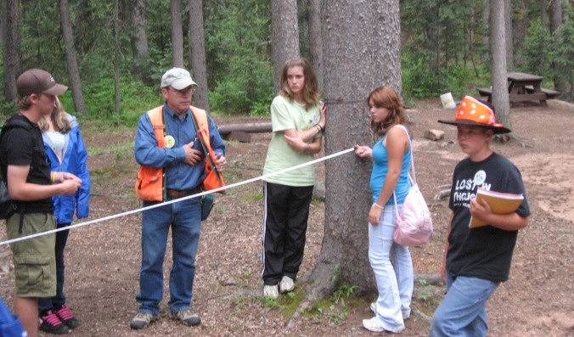

Forest Management
The forestry team learns about different forest types, how to determine the overall health of the forest, how to find a tree’s age without cutting it down, different insects and diseases that affect trees and how fire can be beneficial to forest health and safety.

.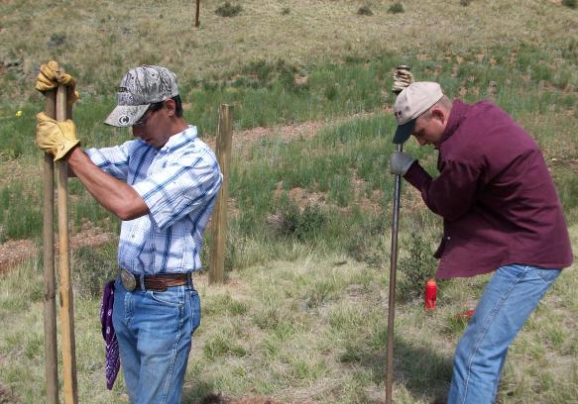

Rangeland Science
The rangeland science group learns about the "fitness" of the rangeland and the forage it provides. They will see how rangelands
provide food for animals, habitat for wildlife, and open space with natural beauty for humans to enjoy, and clean water for drinking and recreation.

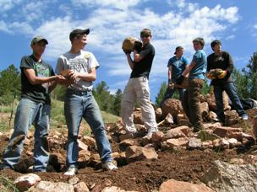
Soil and Water Conservation
This team learns about the primary components of a watershed. They will study a river system and learn how different types of soil affect plants, wildlife, water and humans.

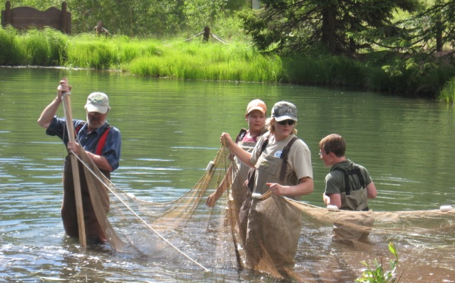
Fish & Wildlife Management
The wildlife biology team will track a radio-collared animal, go electro-fishing, learn how Colorado wildlife adapt to their surroundings and complete a habitat enhancement project.

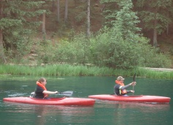

During the Second Half of the Week

- Students work within their groups to develop and present their group natural resource action plans.
- Participants will use their group plan to complete a management project.
- Additional activities include volleyball games, hiking, a campfire, group challenges, and a talent show!

FOR INFORMATION CONTACT:
amy.camprocky@gmail.com
OR CALL CACD @ 719-686-0020
Space limited to first 60 applications.

