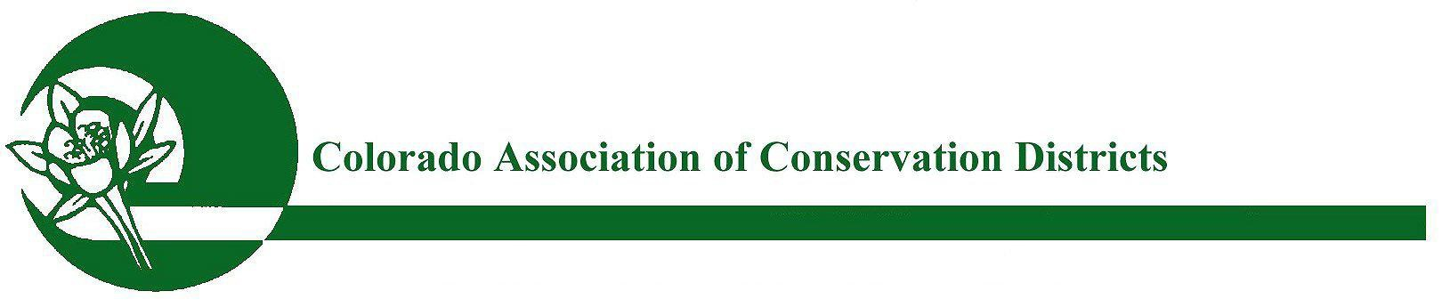
CACD’s 73rd Annual Meeting November 27 - 29, 2017
Embassy Suites Hotel/Conference Center – Loveland, CO

"Conservation...Climbing the Mountain Together"

Monday, November 27th, 2017

9:00 AM-12:00 PM CACD/CSCB Joint Board Meeting 12:00 PM-1:00 PM CACD/CSCB Joint Luncheon
1:00 PM-5:00 PM CACD Board Meeting
1:00 PM-5:00 PM CSCB Board Meeting

4:00 PM-6:00 PM Registration Desk Opens, Poster/Photo Contest & Live Auction Item Check-In
4:00 PM-9:00 PM 2017 Sponsor/Exhibitor Expo Booth Set-up

5:15 PM-6:00 PM Resource Chairman /Committee Review Meeting
6:00 PM-7:30 PM Membership Reception/Happy Hour - Embassy Suites Hotel Atrium

Tuesday, November 28th, 2017

7:30 AM-11:30 AM 2017 Sponsor/Exhibitor Expo Booth Set-up
8:00 AM-5:30 PM Registration Desk Open, Poster/Photo Contest & Live Auction Item Check-In
8:15 AM-8:45 AM Newcomer’s Session
8:15 AM-8:45 AM Facilitator Review Session (if needed) 8:45 AM-11:30 AM GENERAL MEMBERSHIP SESSION
- Color Guard/Pledge of Allegiance
- Invocation - Harold Unwin
- Welcome - Don McBee, CACD President
- Keynote - Motivational Speaker Jeff Evans - MountainVision: Lessons Beyond the Summit
- Jeff Burwell - NACD Western Issues Specialist
- Brent VanDyke - NACD President
- 15 Minute Coffee/Tea Break
- Clint Evans - NRCS CO State Conservationist
- Water Panel Discussion - Becky Mitchell, CWCB Director & Kevin Rein, State Engineer

Tuesday, November 28th, 2017 (Cont’d)

11:30 AM-1:30 PM Luncheon Speaker: Amy Hays – Noble Research Institute (ticketed event) Generational Changes in Conservation

11:30 AM-6:00 PM Posters/Photos Voting
11:30 AM-6:00 PM Silent Auction Bidding Open

3:00 PM-4:30 PM CD Employee Training/Programs – CSCB
4:30 PM-5:30 PM CD Employee’s Association Meeting

2:00 PM-5:00 PM 2017 POLICY RESOURCE COMMITTEE MEETINGS

- District and Association Outlook and Financial
- Soil and Land
- Energy
- Education/Public Outreach (including the Small Acreage/Urban Interface Subcommittee)
- Water

5:30 PM-7:30PM CD Employee’s Association Dinner/Off Site
5:30 PM-7:30PM Dinner on Your Own

7:30 PM-8:15PM Cash Bar & Appetizers – Everyone Welcome! 8:15PM-10:00PM 2017 CACD Live Auction Fund Raising Event

Wednesday, November 29th, 2017

8:00 AM-9:00 AM GENERAL MEMBERSHIP SESSION
  - Morning Welcome
  - Invocation/2017 Departed Recognitions
  - Brett Moore, CACD Lobbyist, 2017 Legislative Review
  - Cindy Lair, Program Manager CSCB - 2017 in Review

9:15 AM-10:45 AM Breakout Session #A - NRCS & CSCB - LWG Statewide Presentation
Breakout Session #B - Small/Limited Budget District Success Panel
NRCS Meeting

10:45 AM-11:00 AM Coffee/Tea Break

9:15 AM-10:45 AM Breakout Session #C - Agriculture and Nutrient Regulations
Breakout Session #D - Aquifer Mapping & Groundwater Resource Management
Breakout Session #E - Riparian Restoration Projects
NRCS Meeting (SWCS Meeting 12:30-5:00 PM)

Wednesday, November 29th, 2017 (Cont’d)

12:30 PM-2:30 PM 2016 CACD Conservation Entertainment & Awards Banquet Luncheon (ticketed event)

12:30 PM Poster/Photo Contest Closes
2:30 PM CD Employees Association Fund Raiser/Silent Auction Bidding Closes
3:00 PM-5:00 PM Expo Display Tear Down
3:00 PM-5:00 PM 2017 CACD GENERAL MEMBERSHIP BUSINESS MEETING

- 2016 Minutes Reading and Approval
- CACD Financial Review and 2018 Budget Approval
- Committee Reports and 2017 Resolution Reading/Voting
- CACD Bylaws Review
- Swearing in of New or Re-elected CSCB/CACD Officers for 2018
- Adjourn

5:00 PM-5:30 PM 2017 AM Program Committee Wrap-up Meeting

Thursday, November 30th, 2017

8:30 AM-10:30 AM CACD November 2017 Board of Directors Meeting

###

