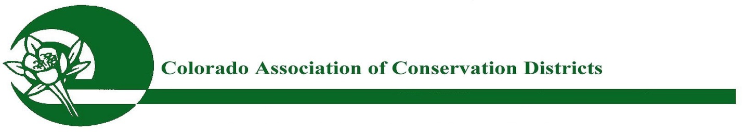
CACD 72nd ANNUAL MEETING BREAKOUT SESSIONS – WEDNESDAY, NOVEMBER 16, 2016
Severance Tax Reductions: Future Effects to District Funding – Carly Jacobs, Budget Analyst with the CO Department of Natural Resources, will speak on severance tax funding for 2017 and the general budget, how this funding is gathered and disbursed, and how this impacts the Conservation Districts, in the area of the DCT and Matching Grants programs. Travis Holland, with Anadarko Petroleum, will also provide additional information from the Oil and Gas Industry perspective. Joy Huse, Chief Financial Officer with the CO Department of Agriculture will address how the CDA receives and then disburses these funds to the various Conservation District programs.
Tools for Stewardship: Opportunities to Help Create Healthy and Resilient Forests – Naomi Marcus, Stewardship Coordinator with the CO State Forest Service (CSFS), will present on funding programs and opportunities for Districts and their landowners that exist through the Colorado State Forest Service (CSFS) and other natural resource agencies to assist in managing healthy property management, to include wildfire mitigation practices, forestry action plans, etc. Amanda Nims, from Colorado Open Lands, will also present.
CO Water Banking, Storage, and ATM’s, and the CWCB Grant Opportunities – John Stulp, Special Policy Advisor to the Governor for Water and Chairman of the IBCC, will provide updates on the issue of water banking, storage, and ATM’s. Anna Mauss, CWCB Finance, will address their programs and funding opportunities to help private landowners.

Conservation Outreach With Changes in Demographic Trends – Elizabeth Garner, State Demographer with the CO Department of Local Affairs, will address CO’s changing demographics. Becca Jablonski, CSU Extension, will provide information on how Ag and natural resource conservation related outreach and communication to landowners, community leaders, and our more urban partners, by our Conservation Districts, will have to adapt and change in some ways, due to trends, increasing urbanization, and the general lack of awareness about our natural resource conservation, agriculture, and land management.
Regulation 85 and Agriculture: Opportunity or Obligation – Andrew Neuhart (Brown and Caldwell), Bill Hammerich (CO Livestock Association) and Mark Sponsler (CO Corn Growers Association) of the CO Ag Task Force will speak about the importance of Regulation 85, specifically how nutrient management has an effect on water quality. Also, how future potential regulation should encourage District engagement in the educational piece of the nutrient management process for their agricultural and private landowners.
CO Water Usage and Oversight for Today and Tomorrow – Steve Witte, CO Division 2 Water Engineer, can address concerns about how water, both Ag and municipal, is being used for either legal hemp or legal/illegal marijuana production. What kind of inspection/regulation/oversight does the state have in place to monitor this particular use of water--our most precious natural resource.

###

