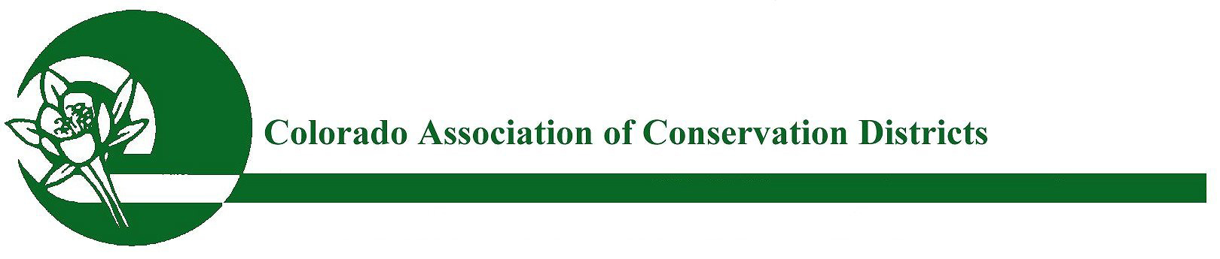
Mailing address: P.O. Box 1175, Lamar, CO 81052

CACD 2022 Education Program of the Year
Excellence Award

PURPOSE:
The purpose of this award is to recognize outstanding and innovative conservation and agricultural educational programs and activities that have proven successful in reaching out to a variety of audiences, involving new partnerships, and spreading the conservation message. Programs that are honored will serve as education models of excellence for other Conservation Districts.

ELIGIBILITY:
All Districts are eligible to participate in this program. The nominee voted through by the watershed to CACD is eligible for receiving the state award unless the nominee has won the “CACD Education Program of the Year” award in the past three years.

APPLICATION & NOMINATION PROCESS:
To nominate your Educational Program, please complete the attached nomination form & submit to your watershed for voting. Please check with your watershed for their deadline date.

Nominations should include a description (1000 words or less) of how your program has implemented conservation education, community outreach, and education events (e.g., tours, school field days, etc.). Also, include the length of time that the program has utilized land stewardship and sound conservation education methods, and the number of people served, along with any long-term conservation goals and plans. The attached nomination word doc form is to be submitted to your watershed and should include a description (1000 words or less) of your District’s success in programs, tours, outreach, and projects. Letter(s) of recommendation from partner agencies and/or agricultural affiliates may be included. Please also submit up to five (5) pictures; in addition to a brief paragraph for promotional purposes.

Once the winner has been chosen by your watershed, the nominating district will need to submit this nomination form (word doc), along with supporting letters & pictures to CACD no later than October 1st.

JUDGING & AWARDS:
Entries will be judged by the CACD Awards Committee. Once a winner is chosen by CACD (by Oct 20th); The nominating district will be asked to summarize this word doc form down to 500 words or less and then submit back to CACD no later than October 26th. The winning program will receive a plaque and be recognized at the CACD Annual Meeting, in November 2022 .

REMINDER: SUBMISSION DEADLINE FOR STATE JUDGING:
Winners chosen from watersheds must be submitted to CACD no later than October 1st, 2022.
Submit nominations to: CACD ED, Bobbi Ketels – bobbi@coloradoacd.org

CONSERVATION EDUCATION PROGRAM OF THE YEAR
2022 NOMINATION FORM

Program Name:

Program Director Name:

Address:

City/Town:

State/Zip:

Telephone:

Email:

*********************************************************************************

Conservation District:

District Manager:

Address/City/Town:

State/Zip:

Telephone:

Email:

Website:

Endorsement:
(Conservation District Board President)

Date:

Please Type District Nominee Endorsement Narrative on Page Two of this “WORD DOC”

Supporting letters of recommendation may be in PDF format.
Pictures submitted MUST be in JPG or PNG FORMAT:

Submit watershed nominations to CACD ED, Bobbi Ketels – bobbi@coloradoacd.org

2022 CONSERVATION EDUCATION PROGRAM OF THE YEAR
NOMINATION NARRATIVE

